**An Economic Analysis of Drinking Water Supply At Islamic University, Kushtia.**



ISLAMIC UNIVERSITY

**Submitted By**

**Roll:** 1907035

**Registration No:** 536

**Session:** 2019-2020

**Department of Economics**

**Islamic University, Kushtia-7003, Bangladesh**

**A Research Report**

Submitted for the course entitled “EC-4206: Field Research and Report Writing” in order to fulfill the academic requirements of the University’s Bachelor of Social Science (BSS) Degree Program

Islamic University, Kushtia-7003, Bangladesh Date of Submission: December, 2024

# An Economic Analysis of Drinking Water

**Supply At Islamic University, Kushtia.**



ISLAMIC UNIVERSITY

**Submitted By**

**Roll:** 1907035

**Registration No**: 536

**Session**: 2019-2020

**Department of Economics**

**Islamic University, Kushtia-7003, Bangladesh**

A Research Report

Submitted for the course entitled “EC-4206: Field Research And

Report Writing” in order to fulfill the academic requirements of the University’s Bachelor of Social Science (BSS) Degree Program.

Islamic University, Kushtia-7003, Bangladesh

Date of Submission: December, 2024

**Declaration**

The researcher, bearing **Roll No: 1907035, Registration No: 536,** a student of **Department of Economics, Islamic University, Kushtia**, hereby declares that the research report titled **“A Study on Economic Analysis of Drinking Water Supply at Islamic University, Kushtia”** has been prepared as part of the academic requirement for the course "Field Research and Report Writing."

The research work is an original one and has been conducted with honesty and integrity. Any information, data, or content taken from other sources has been properly cited and referred. The researcher has not been engaged in any form of academic dishonesty in the preparation of this report.

Furthermore, this report has not been submitted previously, either in whole or in part, for the fulfillment of any other academic or professional requirements.

## Roll: 1907035 Reg: 536 4th Year 2nd Semester Session: 2019-2020 Department of Economics, Islamic University

The above declaration is confirmed by:

## Mr. Md. Humaun Kabir Assistant Professor Department of Economics Islamic University, Kushtia

**Acknowledgement**

All praises are for the Almighty, who bestowed the researcher with the ability and potential to complete this field work successfully undertaken as part of the course requirement of EC-4206: Field Research and Report Writing in the fourth year second semester of the Department of Economics, Islamic University, Kushtia, Bangladesh. The successful conduction of this research work would not have been possible without the inspiration and support of the number of wonderful and a number of respected persons.

First and foremost, the researcher would like to express the sincere gratitude to the respectable supervisor for his assistance, ideas, and feedbacks during the process in doing this Research work. Without his guidance and support, this research work cannot be completed on time. His immense knowledge, profound experience and professional expertise have enabled the researcher to complete this report successfully. The researcher is thankful to him or his precious time in guiding, answering queries, correcting and improving the English in the report. Without his guidance and relentless help, this would not have been possible. The researcher heartily thanks all of the respondents who spontaneously answered the questions and provided additional significant information that helped to analyze the research problem with remarkable insight. Lastly, the researcher wishes to express the sincere gratitude to the family for their encouragement and moral support.

**Table of Contents**

Declaration............................................................................................................................................... iv

Acknowledgement ..................................................................................................................................v

List of Tables ....................................................................................................................................... viii

List of Figures......................................................................................................................................... ix

Abstract ...................................................................................................................................................... 1

CHAPTER ONE ....................................................................................................................................... 2 INTRODUCTION .................................................................................................................................... 2

1.1 Background of the Study............................................................................................................. 3

1.2 Problem Statement ........................................................................................................................ 4

1.3 Study Rationale ............................................................................................................................... 6

1.4 Research Questions ....................................................................................................................... 7

1.5 Objectives of this Study ............................................................................................................... 7

1.6 Significance of the study ............................................................................................................. 8

1.7 Scope of this Research ................................................................................................................. 9

1.8 Organization of the Report ...................................................................................................... 10

CHAPTER TWO .................................................................................................................................... 12 Review of Related Literature ........................................................................................................ 12

2.1 Review of Related Literature .................................................................................................. 13

2.2 Research Gap.................................................................................................................................. 14

CHAPTER THREE ................................................................................................................................ 16

Conceptual Framework ................................................................................................................... 16

3.1 Conceptual Framework ........................................................................................................ 17

CHAPTER FOUR................................................................................................................................... 19 Methodology of the Study ............................................................................................................... 19

4.1 Research Framework ................................................................................................................. 20

4.2 Research Hypotheses ................................................................................................................. 21

Hypotheses for Ordinal Regression Model ................................................................................. 21

4.3 Research Design ........................................................................................................................ 22

4.4 Sampling ...................................................................................................................................... 22

4.5 Study Location ........................................................................................................................... 23

4.6 Operational Definition............................................................................................................. 23

4.7 Measurement of Variables .................................................................................................. 25

4.8 Data Collection ......................................................................................................................... 25

4.9 Data Collection Procedures ................................................................................................... 27

4.10 Techniques of Data Analysis.................................................................................... 28

CHAPTER FIVE ..................................................................................................................................... 31 Findings and Discussion .................................................................................................................. 31

5.1 Introduction ...................................................................................................................................... 32

5.2 Descriptive Information ............................................................................................................... 32

5.2.1Age of

Respondents ..................................................................................................................................... 32

5.2.2Willingness to pay for pure water quality by individual .......................................................................................................................................... 33

5.2.3Individual satisfaction for water consumption ..................................................................................................................................... 34

5.2.4Daily water consumption ..................................................................................................................................... 35

5.2.5Water Quality

Valuation ........................................................................................................................................... 36

5.2.6Water Distribution Per Daily

Uses .................................................................................................................................................... 37

1. 2.7Contamination water can impact health issues .................................................................................................................................................. 39

5.3 Inferential Statistics ....................................................................................................................... 41

5.3.1Ordinal Regression

Analysis ............................................................................................................................................. 41

5.3.2 .............................................................................................. Hypothesis

Testing ............................................................................................................................................... 47

CHAPTER SIX ..................................................................................................................................... 49 Conclusion and Recommendations ................................................................................................ 49

6.1 Conclusion ........................................................................................................................................ 50

6.2 Recommendations ...................................................................................................................... 52

References ............................................................................................................................................... 56

# List of Tables

**Table 1**: Daily water Consumption (Liters)……………………35

**Table 2**: Derivatives for water supply results………………… 38

**Table 3**: Contamination water impacted health issues…………39

**Table 4:** Health issues perception …………………………… 40

## Table 5: Satisfaction of drinking water supply and WTP…… 40

**Table 6**: Dependent and Independent Variable relationships…. 41

**Table 7**: Method Valuation fit………………………………… 42

**Table 8:** Ordinal Regression output……………………………43

**Table 9:** R-Square Value Output………………………………43

**Table 10:** Parameter estimates for variables…………………….45

## Table 11: Hypothesis Testing………………………………… 48

**List of Figures**

**Figure 5.1:** Age Structure of Respondents………………… 32

**Figure 5.2:** Willingness to pay of Respondents…………… 33 **Figure 5.3:** Satisfaction with drinking water consumption… 34

**Figure 5.4:** Daily Water Consumption pattern……………… 35

**Figure 5.5:** Perceived Water Quality Values………………… 36

**Figure 5.6:** Efficiency of the water distribution system…… 37

**Figure 5.7:** Water Distribution daily uses…………….…… 37

# Abstract

*This study conducts a comprehensive economic analysis of the drinking water supply system at Islamic University, Kushtia, assessing its cost-efficiency, operational sustainability****,*** *and socioeconomic implications. The objective is to evaluate the financial feasibility of the current system, identify economic inefficiencies, and ensure equitable access to potable water. Employing a mixedmethods research design, the study integrates quantitative surveys, cost-benefit analysis (CBA), and**Ordinal regression modeling to examine user perceptions, willingness to pay, and the structural efficacy of water distribution. The findings reveal that perceived water quality and distribution efficiency are the most significant determinants of user satisfaction, while affordability constraints limit financial sustainability. Despite the presence of contaminants such as iron and**arsenic, awareness levels remain low, potentially influencing the demand for infrastructural improvements. The study underscores the urgent need for policydriven interventions, including the implementation of advanced water purification technologies, AI-powered distribution**management systems, and renewable energy integration to enhance long-term sustainability. However, institutional financial limitations and governance inefficiencies pose formidable challenges to immediate reform. Limitations include sample size constraints and reliance on self-reported data.*

***Keywords:*** *Economic analysis, water supply, Cost benefit evaluation, Sustainability*



**CHAPTER ONE**

**INTRODUCTION**

## 1.1 Background of the Study

Clean and safe drinking water is vital for health and well-being, especially at Islamic University, Bangladesh, serving students, staff, and the surrounding community. This study examines the economic aspects of the university’s water supply, focusing on costs, efficiency, and sustainability. Challenges such as groundwater contamination, inefficient infrastructure, and rising demand strain the current system. The research aims to assess economic impacts and propose cost-effective, sustainable solutions to improve access and resource management. Findings will guide policy and infrastructure planning for a more equitable and efficient water supply system. Collectively, this research aims to provide a comprehensive economic evaluation that can be used in the development of decision-making and investment frameworks for water infrastructure in the future. In institutional settings where demand is high and resource management easy, providing safe and affordable potable water access — which is at the heart of public health and economic advancement–is a formidable challenge. The provision of safe drinking water to its students, faculty and staff presents both challenges for improvement [1]. Groundwater remains at the heart of water supply in the area, but it has come under increasing pressure, needing to contend with contamination, infrastructure inefficiencies and growing demand.

The expansion of the Indian University (IU) campus and its student population increase as well have created a greater need for drinking water supply, a trend that shows why an economically sustainable and efficient system is needed at IU. Other issues like: Expensive treatment, lack of infrastructure for distribution efficiency and socioeconomic ramifications of water price will demand greater inquiry as well [2]. This study is rooted in the connectedness of the economic viability of desalination, environmental sustainability, and equitable access to drinking water. The overall goal of this research is to perform a comprehensive benefit-cost analysis approach to the IU drinking water supply. The purpose is to assess the water supply system cost elements, analyze the economic effects of poor water quality on society and propose financially sound measures for enhanced access to safe drinking water and more efficient distribution. Drawing on recent data for groundwater quality and demand patterns — and coupled with state-of-the-art economic modelling to evaluate both the direct and indirect costs of water provision — the study will provide insights. In doing so, the research aims to contribute to international debates around sustainable water governance in semi-arid regions. The findings are anticipated to provide practical recommendations for IU and other comparable institutions in Bangladesh so that the drinking water supply systems are robust, economical, and inclusive [3].

## 1.2 Problem Statement

Access to safe, reliable, and economically sustainable drinking water remains a persistent challenge for academic institutions, yet Islamic University, Kushtia, grapples with critical inefficiencies in its water supply system. Despite being an essential resource for students, faculty, and staff, the university’s water infrastructure exhibits significant deficiencies in quality, financial viability, and operational efficiency, raising concerns regarding its long-term sustainability.

A primary concern is the deteriorating water quality, with contaminants such as arsenic, iron, and microbial pollutants posing substantial health risks. While groundwater contamination is a well-documented issue in Bangladesh, limited research explores the relationship between perceived water quality, consumption behavior, and willingness to pay within institutional settings. Additionally, irregular distribution, low water pressure, and aging infrastructure contribute to supply inconsistencies, exacerbating operational inefficiencies and increasing user dissatisfaction.

From an economic perspective, the financial sustainability of the water supply system remains uncertain. The escalating costs of maintenance, infrastructure expansion, and water treatment are compounded by inadequate budget allocations and the absence of cost-recovery mechanisms. The lack of institutional investment, inefficient pricing structures, and minimal stakeholder engagement further constrain the feasibility of long-term improvements.

Although global studies underscore the importance of integrating smart infrastructure, sustainable financing, and policy-driven governance in water management, there is a notable absence of empirical data on the economic trade-offs associated with institutional drinking water supply in Bangladesh. Without strategic intervention, these inefficiencies will intensify, jeopardizing both financial and environmental sustainability.

This study seeks to address these challenges by conducting a comprehensive economic analysis, integrating cost-benefit modeling, user perception assessment, and sustainable policy recommendations to inform a more financially viable and environmentally resilient framework for water governance in higher education institutions.

## 1.3 Study Rationale

Access to clean and affordable drinking water is essential for the health and productivity of students, faculty, and staff at Islamic University, Kushtia. However, issues such as infrastructure water contamination, irregular supply, and inadequate pose significant challenges. The presence of iron, arsenic, and microbial pollutants raises serious health concerns, while inefficiencies in the distribution system increase operational costs and disrupt daily activities. Additionally, economic constraints andbudget limitations affect the university’s ability to maintain and improve water infrastructure.

This study is necessary to analyze the economic efficiency**,** affordability, and sustainability of the existing water supply system. By evaluating cost structures, pricing mechanisms, and supply chain inefficiencies, the research will provide data-driven recommendations for improving water accessibility, quality, and financial sustainability. The findings will assist university administrators and policymakers in making informed decisions to enhance water management and ensure a safe and reliable supply for all users.

## 1.4 Research Questions

This study will address the following research questions:

1. What are the direct and indirect economic costs associated with the drinking water supply system at Islamic University, Bangladesh?
2. How efficient and sustainable is the current water supply mechanisms at IUK?
3. What are the impacts of the existing water pricing structure on consumption and accessibility among students and faculty members?
4. What are the impacts of the existing water pricing structure on consumption and accessibility among students and faculty members?

## 1.5 Objectives of this Study

The overall objective of this study is to examine a comprehensive economic analysis of the drinking water supply to evaluate the total costs and benefits [5]. It will also examine the broader economic impacts of the water supply on the university community, considering factors such as affordability, productivity, and public health. Some specific points in below:

1. To assess the economic costs (capital and operational) of the drinking water supply system at Islamic University.
2. To evaluate the efficiency of the water supply infrastructure and identify areas of improvement.
3. To analyze the social, health and economic impacts of water accessibility and affordability on the university community.

To propose recommendations for improving the water supply system in terms of cost-effectiveness.

## 1.6 Significance of the study

This work is extremely exigent, as it speaks to fundamental aspects of development, health and resource use very close to institutional realities. The objective of the paper is to promote proper resource management by identifying cost structures and identifying inefficiencies related to the water supply chain. It covers waste minimization, maintenance of the infrastructure, and low-cost treatment technologies. With its modest budgets, IU has no choice; efficiency is vital to water management as operating costs rise. The research complements the global aim in regards to sustainability by studying green technologies and practices, looking at aspects such as water recycling, renewable energy to make integrated solution for pumping & rehabilitation system (a sustainable water supply system), not just addressing contemporary issues but also making future resilience towards the problem of water crunch & weather related concerns involved will ensure that. Over a longer term the study will analyze the socioeconomic impacts of water pricing on the university community, with particular regard to low income students and staff. Through a socially responsible water policy centered on economic development and inclusion, the goal of the study is the look at will also contributing to instructional literature and sensible answers in water useful resource manage as one of the first precise monetary analyses of water supply at IU.

## 1.7 Scope of this Research

The scope of this research on the economic analysis of drinking water supply at Islamic University (IU), Bangladesh, encompasses several key dimensions of water management, quality assessment, economic impact, and policy recommendations, focusing on both current challenges and future solutions. This study will comprehensively evaluate the present-day water supply system at IU, which include resources (especially groundwater), treatment strategies, distribution mechanisms, and infrastructure condition [4]. The scope will cowl each operational and capital charges related to water supply, highlighting inefficiencies, and assessing how those impact the overall monetary sustainability of the device. Groundwater pleasant troubles, particularly contamination by way of iron, arsenic, and microbial pollution, will be a giant consciousness. The have a look at will examine the volume of contamination across specific areas of the university campus and investigate the associated expenses of water purification, including treatment technology and preservation prices. A specified financial assessment will be undertaken, such as direct charges (treatment, maintenance, electricity, and many others.) and indirect expenses (fitness-associated impacts, productivity losses, and educational disruptions due to waterborne illnesses). The look at can even evaluate the economic burden of water supplyassociated troubles with the college’s universal finances to become aware of capacity areas for cost reduction. The study will examine water call for patterns among college students, faculty, and workforce, analyzing factors inclusive of population boom, seasonal version, and water utilization behaviors. It may even determine how those styles impact each the ability of the water deliver gadget and the monetary feasibility of preserving or expanding infrastructure.

## 1.8 Organization of the Report

1. This research report is structured into six chapters, each focusing on a key aspect of the study. **Introduction** provides an overview of the research, including the background, problem statement, study rationale, objectives, research questions, and the organization of the report. It sets the foundation for understanding the importance of analyzing the economic aspects of drinking water supply at Islamic University, Kushtia.
2. **Literature Review** explores existing research on water supply systems, economic efficiency, cost-benefit analysis, and sustainability. It highlights gaps in previous studies and establishes the need for this research.  **Research Methodology** outlines the research design, data collection methods, sampling techniques, and analytical approaches used to evaluate the water supply system's economic and infrastructural aspects.
3. **Data Analysis and Findings** presents the results derived from survey responses, statistical analyses, and observations. It provides insights into the availability, quality, and affordability of

drinking water on campus. **Discussion and Interpretation** examines these findings in relation to existing literature, identifying key challenges and their implications for sustainable water management.

1. Finally, **Conclusion and Recommendations** summarizes the study’s major findings, offering practical recommendations to improve the efficiency, cost-effectiveness, and sustainability of the water supply system. This structured approach ensures a logical flow of information, making it easier to understand the economic dynamics of the university’s drinking water supply.



**CHAPTER TWO**

**Review of Related Literature**

## 2.1 Review of Related Literature

Numerous studies have analyzed the economic analysis of drinking water supply, with findings suggesting results. Some current research papers are follows: This article has studied the analysis of drinking water services of the city of Souk-Ahras (Algeria). The study explored constrains that budget imbalance effects on high level of non-revenue water and the application of pricing that does not achieve cost recovery. The study suggested that the policymakers can improve the quality of water supply chain associated with economic sustainability. However, this paper didn’t discuss the environmental degradation and water demand-supply gap. Mishra V., Dasani P., Gandhi N., Mehta D., 2016, the researchers analyzed the drinking water supply in rural areas. They showed how the rapid growth populations responsible for inefficient water supply chain. From 27% to 32% in 2001 and enhancing rises population increase to 50% by 2050, in this phenomenon, around 50% do not have sewerage connection and less than 20 % of waste water is treated. They also explain in this paper that the cost evaluation of water supply.

Merch´an-Sanmart´ın B., Carri´on-Mero P., Su´arez-Zamora S., 2022, the authors studied on a university campus planning management of the drinking water resources project. This study aims to elaborate the drinking water master plan by analyzing the existing situation and applying technical-sustainable criteria to efficiently manage the current and future water resources of a university campus. Therefore, the project was environmentally and economically viable for campus expansion purposes. Sj¨ostrand K., Sj¨ostrand A., S¨oderqvist T., Rosen L., 2019, they analyzed Cost Benefit Analysis on Drinking Water Supply. The objective of this study is to understand the cost-benefit analysis approach to assess the societal effects of regional water supply interventions to constitute support for decision makers. They formulated the quantification of effects on consumers’ health, water supply reliability, and operation and maintenance costs. Ali G., Khalid M., Abbas S., Murtaza M., 2021, This study focuses to measure the efficacy of drinking water in terms of the economic impacts and risk of illness involved in using perilous water sources. The sample size was 210 and they found that the average cost of illness was higher in peril-urban ($10.79 USD) areas, while willingness to pay for quality water was higher in urban residents. They suggested that public-private partnership could work to provide affordable quality drinking water.

## 2.2 Research Gap

While extensive studies have examined the economics of urban and rural water supply, institution-specific economic analyses of drinking water systems in Bangladeshi universities remain largely unexplored. Existing research predominantly focuses on municipal water pricing, cost-recovery mechanisms, and public health implications but lacks a comprehensive economic evaluation tailored to higher education institutions. Additionally, although water contamination risks—such as arsenic and microbial pollutants—are well-documented in Bangladesh, the interplay between perceived water quality, willingness to pay, and consumption behavior in academic settings remains underexplored.

Moreover, prior studies fail to integrate financial constraints, infrastructure inefficiencies**,** and governance limitations into a cost-benefit framework to assess the long-term sustainability ofinstitutional water supply systems. This study addresses these critical gaps by employing economic modeling, user perception analysis, and policy-driven recommendations, offering a datadriven framework for sustainable water governance in public universities.



**CHAPTER THREE**

**Conceptual Framework**

### 3.1 Conceptual Framework

The conceptual framework of this study provides a structured approach to analyzing the economic aspects of the drinking water supply system at Islamic University, Kushtia. It integrates economic theories, sustainability principles, and policy considerations to assess the efficiency, affordability, and long-term viability of the water supply system. This research primarily focuses on four key dimensions: water supply system efficiency**,** economic cost-benefit analysis, user perception and willingness to pay (WTP**),** and sustainabilityconsiderations.

The study is built upon Cost-Benefit Analysis (CBA) Theory, which evaluates whether the benefits of the university’s current water supply system outweigh its operational costs. By analyzing direct costs (infrastructure, maintenance, energy) and indirect **costs** (health risks, productivity losses), the research identifies inefficiencies in financial planning. Additionally, Public Goods and Utility Pricing Theory plays a crucial role in understanding how the pricing mechanism affects accessibility and affordability, ensuring that water remains both economically viable and socially equitable. The study also incorporates Sustainable Resource Management Theory, emphasizing the need for long-term strategies like renewable energy solutions, water recycling, and efficient infrastructure development to mitigate rising operational costs and environmental concerns.

From an analytical perspective, the research examines three primary independentvariables: water supply system quality, operational **costs**, and pricing structures. These influence dependent variables such as user satisfaction, willingness to pay (WTP), and economic sustainability. Through a structured survey, interviews**,** and institutional dataanalysis, this study assesses the impact of these variables on the overall economic efficiency of the university’s drinking water system. Key hypotheses tested include the inefficiency of the current system, inadequacy of existing pricing mechanisms, and potential cost savings from infrastructure improvements.

The conceptual model highlights the interaction between these factors. A well-maintained and efficiently operated water supply system can improve cost-effectiveness, increase user satisfaction, and ensure long-term financial sustainability. The research aims to provide policy recommendations on budget allocation, alternative pricing models, and investment in sustainable infrastructure to improve the quality and affordability of drinking water at Islamic University.



**CHAPTER FOUR**

**Methodology of the Study**

## 4.1 Research Framework

The research framework of this study establishes a structured approach to analyzing the economic aspects of the drinking water supply system at Islamic University, Kushtia. It integrates economic theories, financial evaluation models, and sustainability principle**s** to assess the efficiency, affordability, and long-term sustainability of the system. This framework serves as a foundation for identifying key variables, analyzing economic implications, and providing policy recommendations. The study applies Cost-Benefit Analysis (CBA) Theory, which evaluates whether the financial resources allocated to the water supply system yield economic benefits. Additionally, Public Goods and Utility Pricing Theory helps assess whether the university’s pricing model ensures both affordability and financial sustainability. The study also incorporates Sustainable Resource Management Theor**y** to explore renewable energy integration, infrastructure improvements, and long-term water conservation strategies.

The framework identifies independent variables, such as water supply system efficiency, operational costs, and pricing structure**s**, and their influence on dependent variables, including user satisfaction, willingness to pay (WTP), and economic sustainability. The study hypothesizes that the current water supply system is economically inefficient, pricing mechanisms do not reflect true costs, and infrastructure improvements can enhance financial viability. A conceptual model visually represents the interaction between water supply efficiency**,** financial factors, and user perceptions, demonstrating how these elements impact the system’s economic sustainability. The framework is applied throughout the research through data collection (surveys, interviews, institutional reports), statistical analysis (CBA, regression, efficiency modeling), and policy evaluations. The findings will contribute to cost-effective budget planning, optimized pricing strategies, and sustainable infrastructureinvestments. By adopting this structured approach, the research aims to provide actionable recommendations for improving economic efficiency, affordability, and long-term sustainability in the university’s water supply management.

## 4.2 Research Hypotheses

### Hypotheses for Ordinal Regression Model

**Null Hypothesis (H0)**: There is no significant relationship between the independent variables (water consumption, perceived water quality, awareness of contamination, willingness to pay, and efficiency of water distribution) and satisfaction with the cost of drinking water.

**Alternative Hypotheses:**

**H1**: Higher daily water consumption has a positive effect on satisfaction with water cost.

**H2**: Better perceived water quality increases satisfaction with water cost.

**H3**: Awareness of contamination negatively impacts satisfaction with water cost.

**H4**: Higher willingness to pay for improved water quality positively affects satisfaction with water cost.

**H5**: Greater perceived efficiency of water distribution positively influences satisfaction with water cost.

#### 4.3 Research Design

This study have used a mixed-method approach, combining quantitative analysis with qualitative interviews to explore the economic significance of drinking water supply phenomenon and also use Ordinal Regression Model to clarify variable outputs.

#### 4.4 Sampling

This study uses stratified random sampling to ensure a representative sample of 100 student respondents from different academic years and departments. The sample size is determined based on feasibility, resource availability, and time constraints. Proportional representation across gender, academic disciplines, and study levels will be maintained to enhance generalizability. This approach ensures diverse perspectives while balancing statistical reliability and practicality. A margin of error analysis will assess the reliability of the findings. The selected sample provides meaningful insights into the university’s drinking water supply, allowing for informed economic and policy recommendations.

#### 4.5 Study Location

This study will be conducted in Islamic University Campus area Kushtia District, Bangladesh. A purposive sampling method will be used in selecting specific data for ensuring economic analysis of drinking water supply.

Location:

Islamic University Campus Area

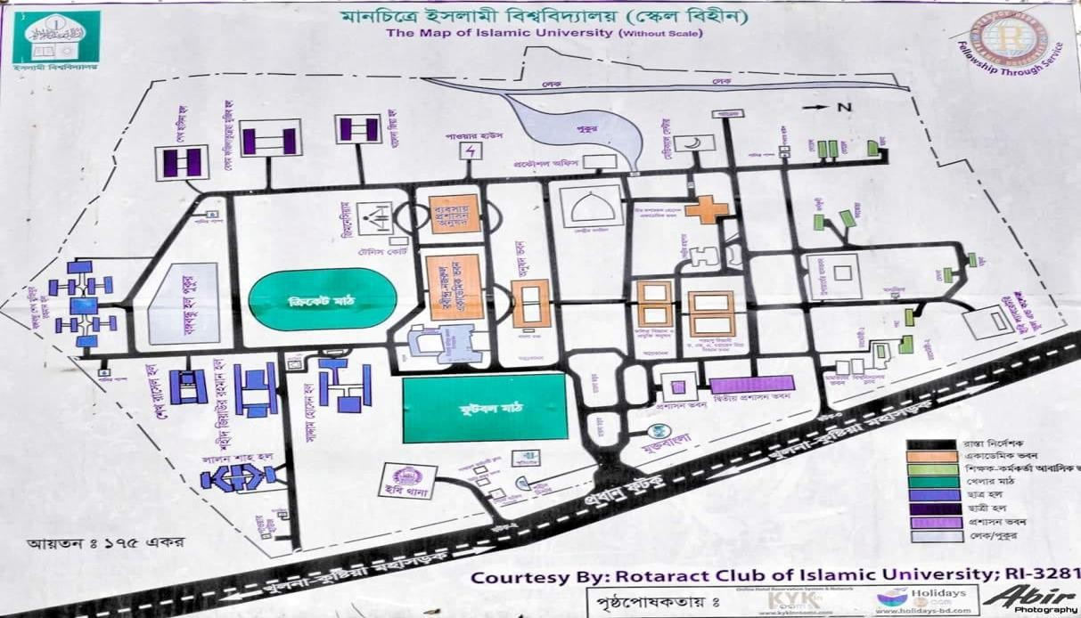

#### 4.6 Operational Definition

The operational definition of this study establishes a structured approach to analyzing the economic aspects, health implications, and sustainability of the drinking water supply at Islamic University,

Kushtia. The study assesses key components such as water accessibility, quality perception, cost efficiency, health-related risks, and economic sustainability to determine the effectiveness of the current system. Drinking water supply in this context refers to the sourcing, treatment, and distribution of potable water within the university, primarily relying on groundwater. The economic analysis evaluates capital investments, operational costs, and pricing structures, employing cost-benefit analysis (CBA) to measure financial efficiency and affordability.

Water accessibility is defined by the ease with which students, faculty, and staff can obtain safe drinking water, considering factors such as availability, dependence on alternative sources, and supply reliability. Water quality perception is assessed based on taste, odor, color, and awareness of contamination, such as arsenic, iron, or microbial pollutants, which can have direct health consequences. Contaminated or insufficient water supply can lead to waterborne diseases like diarrhea, gastrointestinal infections, and long-term health conditions such as arsenic poisoning, which significantly affect student productivity and overall well-being.

The effectiveness of the system is evaluated under system efficiency, which considers distribution mechanisms, water waste, infrastructure maintenance, and equitable access. Lastly, sustainability is examined in terms of long-term resource management, infrastructure resilience, budget allocation, and the integration of eco-friendly solutions such as renewable energy for water pumping and water recycling initiatives.

**4.7 Measurement of Variables**

#### Dependent Variable

1. Satisfaction with the cost of drinking water (Ordinal, Likert Scale)

Measurement Scale: Continuous (Numeric)

#### Independent Variables

1. Daily water consumption (ordinal: Less than 2 Liters, 2-5 Liters)
2. Perceived water quality (ordinal: Poor, Average, Good, Excellent)
3. Awareness of Contamination (categorical: Yes = 1, No = 0)
4. Willingness to Pay (Ordinal: below 100 BDT, 100-200 BDT)
5. Efficiency of Water distribution (Ordinal: 1 to 5 scale)

##### 4.8 Data Collection

1. **Secondary Data:** This study will rely on data from the Institutional records (financial reports, maintenance logs, and water usage documents) and economic statistics. Additionally, data from Bangladesh Bureau of Statistics (BBS).
2. **Primary Data Collection:** A structured questionnaire will be used to collect the data. The sections of the questionnaire will be
3. **Demographic** and Water Availability Features: Age, Gender, Department, Water Usage and quality measurement.

Satisfaction of Drinking water (Daily uses).

1. **Economic Features**: Students view can be varied willing to pay for improved water quality and reliability, budget constraints and cost of accessing water. Sample questions below- “How much are you willing to pay per month for improving water quality and reliability?” (Options: Below 100 TK/ 100-200 TK. And above). “Do you think the university authority allocates sufficient budget for water supply?” (Options: Yes/No).

“How satisfied are you with the cost of access water on campus?” (Options: Very satisfied, satisfied, neutral, dissatisfied, very dissatisfied).

1. **Health Risks:** Self-reported health issues linked to water consuming like symptoms of water diseases or finding heavy metal e.g., Arsenic, Iron, Lead etc.

Sample Question:

“Are you aware of any reported contamination in the water supply e.g., Arsenic, Iron, Lead, Cadmium, Chloride and other toxic substance?” (Options: Yes/No)

“Have you or someone you know experienced health issues specially Diarrhea, Typhoid fever, Cholera potentially related to the University’s drinking water?” (Options: 1 = Yes, 2=No)

1. **Suggesting Water Values**: How can be we improved water supply values in order that I checked about 100 respondents, they ensured that when we can apply water recycling

and purifying machine system and support for better quality initiatives then we perfectly evolved.

Sample Question:

“Would you support initiatives like water recycling or renewable energy for water pumping?” (Options: Yes/No).

“Would you support initiatives to get better water quality to set up water purifying machine in specific area of the campus?” (Options: Yes/No).

###### **4.9 Data Collection Procedures**

The data collection process spans 4-6 weeks, ensuring a high response rate while maintaining data reliability and validity.

#### A. Questionnaires

Distributed to University present students to gather quantitative data for water supply on economic factors, Health issues, satisfaction level and decision-making. Includes closed and open-ended questions.

#### B. Interviews

Semi-structured interviews with Students, health professionals, and environmental experts to gather in-depth insights on health threats, environmental impacts, and awareness.

##### C. Focus Group Discussions

Group discussions with Students to explore their awareness of health and environmental impacts of drinking water issues and share experiences and opinions.

###### **4.10 Techniques of Data Analysis**

The data collected through the surveys will be analyzed using SPSS (Statistical Package for the Social Sciences). The following statistical techniques will be applied:

1. **Descriptive Statistics:** Demographic, economic, and health impact data will be summarized using frequency distributions, means, mode, variance, and proportions.

1. **Inferential Statistics:** Multiple Linear Regression Analysis: To find out the impact of health, satisfaction, awareness and initiatives for water sustainability.

**Regression Analysis:** Ordinal Regression model to identify key predictors of among students. This will help assess the impact of health issues, satisfaction level, risk-taking behaviour, and other factors. Stepwise Regression applied to determine the most influential factors by entering variables into the model step by step. All analyses will be conducted at a **significance level of 5%** (p-value < 0.05) to determine the strength and reliability of the findings.

**Ordinal Regression Model:**

To determine the effect of health, Cost, awareness, and satisfaction on the campus area under Islamic University. The dependent variable (Satisfaction with drinking water cost) is ordinal(Likert scale: 1 = Very Dissatisfied to 5 = Very Satisfied), the Ordered Logit (OrdinalRegression) Model is valued.

In this research, the Ordinal Regression Model is used to analyze the determinants of satisfaction with drinking water costs at Islamic University, Kushtia. Given that the dependent variable (Satisfaction with Water Cost) is ordinal(measured on a Likert scale: 1 = Very Dissatisfied to 5 = Very Satisfied), the Ordered Logit Model is applied for estimation. The relationship between the dependent variable and independent variables will be analyzed using an Ordinal Regression Model.

**ϵ**

𝑷(𝒀>𝒋)

Where;

* Y: Satisfaction with water cost (Ordinal outcome: 1 = Very Dissatisfied to 5 = Very Satisfied)
* j: category of satisfaction (e.g., 1= very dissatisfied, 2= dissatisfied,……,5= very satisfied)
* P(Y<=j): Cumulative probability of being in category j or below
* αj = Threshold for category j
* X1: Daily water consumption (Ordinal: Less than 2L, 2-5L, more than 5L)
* X2: Perceived water quality (Ordinal: Poor, Average, Good, Excellent)
* X3: Awareness of contamination (Categorical: Yes = 1, No = 0) • X4: Willingness to Pay (Ordinal: Below 100 BDT, 100-200 BDT, 200+ BDT)
* X5: Efficiency of water distribution (Ordinal: 1 to 5 scale)
* β1, β2, β3, β4,β5: Regression coefficients showing the effect of each independent variable on satisfaction
* ϵ: Error term



**CHAPTER FIVE**

**Findings and Discussion**

### 5.1 Introduction

In this chapter, we have found the results of models adopted in the previous chapter and discussed these results to fulfill our objectives. This chapter consists of three parts: such as, descriptive statistics, inferential statistics, and empirical model. All the parts helped to enhance the reliability of the study.

### 5.2 Descriptive Information

#### 5.2.1 Age of Respondents

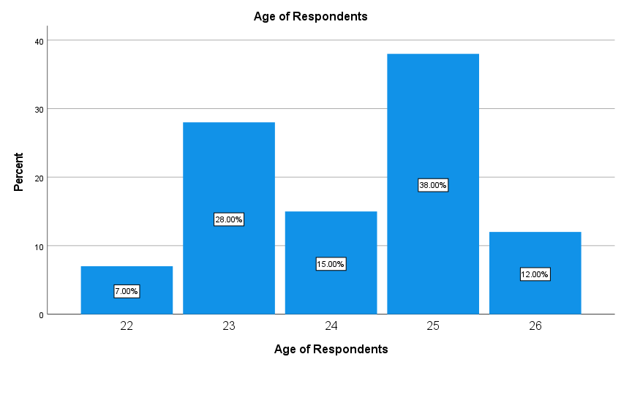

**Figure 5. 1:** Age Structure of Respondents

The bar chart shows the age distribution of respondents. The majority (38%) are 25 years old, followed by 23 years (28%) and 24 years (15%). Only 12% are 26 years old, while the smallest group (7%) is 22 years old. Age 25 is the most common among respondents.

##### 5.2.2 Willingness to pay for pure water quality by individual

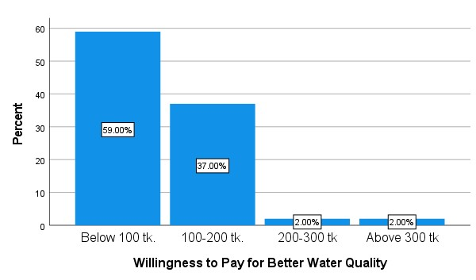

**Figure 5.2:** Willingness to pay of Respondents

The bar chart shows respondents' willingness to pay for better water quality. The majority (59%) are willing to pay below 100 TK, while 37% are willing to pay between 100-200 TK. Only 2% are willing to pay 200-300 TK or above 300 TK, indicating limited financial commitment.

##### 5.2.3 Individual satisfaction for water consumption

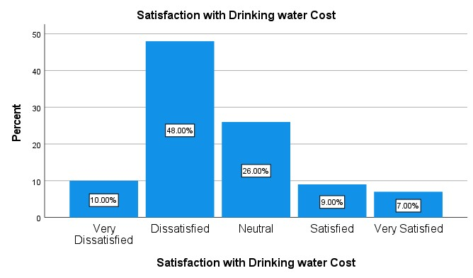

**Figure 5.3:** Satisfaction with drinking water consumption

The table shows respondents' satisfaction with drinking water costs. Nearly half (48%) are **dissatisfied**, while 26% are **neutral**. Only 9% are **satisfied**, and 7% are **very satisfied**. About 10% are **very dissatisfied**. Overall, dissatisfaction predominates, with just 16% expressing satisfaction.

**5.2.4 Daily water consumption**

##### Daily water Consumption (Liters)

|  |  |  |  |  |  |
| --- | --- | --- | --- | --- | --- |
| Frequency | | | Percent | Valid  Percent | Cumulative  Percent |
| Valid | Less than 2 Liters | 39 | 37.9 | 39.0 | 39.0 |
|  | 2-5 Liters | 61 | 59.2 | 61.0 | 100.0 |
| Total | 100 | 97.1 | 100.0 |  |
| Missing System | | 3 | 2.9 |  |  |
| Total | | 103 | 100.0 |  |  |

**Table 1**: Daily water Consumption (Liters)

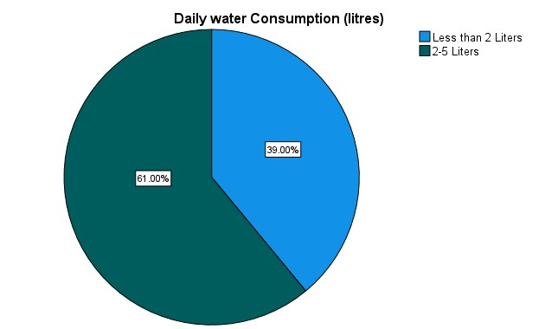

**Figure 5.4:** Daily Water Consumption pattern

The table shows daily water consumption among respondents. Most (61%) consume **2-5 liters** per day, while 39% consume **less than 2.**

###### **5.2.5 Water Quality Valuation**

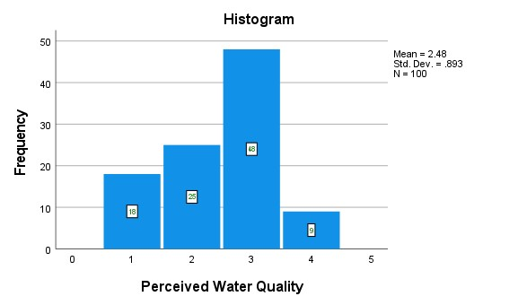

**Figure 5.5:** Perceived Water Quality Values

The histogram shows perceived water quality ratings, with most respondents (48) rating it as 3. Ratings of 1, 2, and 4 received 18, 25, and 9 responses, respectively. The mean score is 2.48, with a standard deviation of 0.893, based on a sample size of 100.

###### **Efficiency Of the distribution System**

The histogram illustrates the efficiency of the water distribution system based on survey responses. Most respondents (43) rated efficiency as 2, followed by 25 selecting 3. Ratings of 1 and 4 received 16 responses each. The mean score is 2.41, with a standard deviation of 0.944, based on 100 participants.

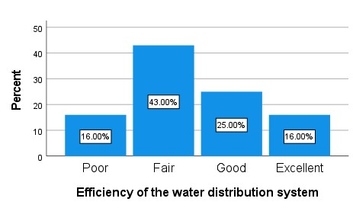

**Figure 5.6:** Efficiency of the water distribution system

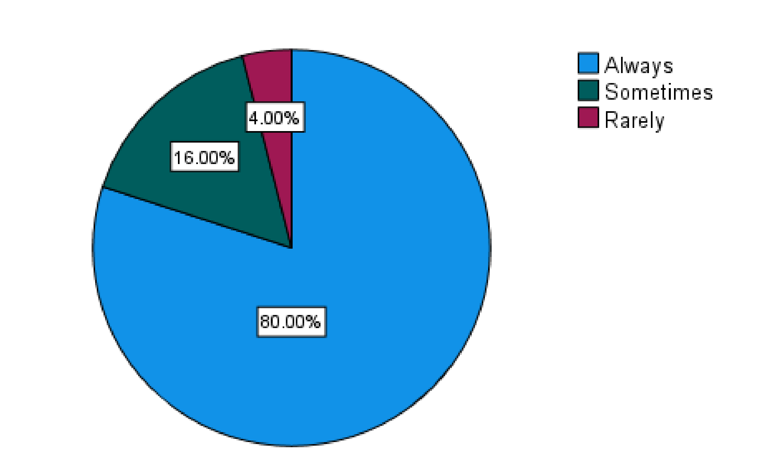**5.2.6 Water Distribution Per Daily Uses**

**Figure 5.7:** Water Distribution Per daily uses

##### Descriptive Statistics

|  |  |  |  |  |
| --- | --- | --- | --- | --- |
|  | N | Mean | Std. Deviation | Variance |
| Daily water  Consumption (liters) | 100 | 1.6100 | .49021 | .240 |
| Satisfaction with  Drinking water Cost | 100 | 2.55 | 1.029 | 1.058 |
| Efficiency of the water distribution system | 100 | 2.41 | .944 | .891 |
| Valid N (listwise) | 100 |  |  |  |

**Table 2**: Derivatives for water supply result

The descriptive statistics table provides an overview of three key variables: daily water consumption, satisfaction with drinking water cost, and the efficiency of the water distribution system. The mean daily water consumption is 1.61 liters, with a standard deviation of 0.49, indicating that most respondents have a consistent and relatively low water intake. In contrast, satisfaction with drinking water cost has a mean value of 2.55 and a standard deviation of 1.03, reflecting moderate variability, suggesting differing levels of satisfaction among respondents. Similarly, the efficiency of the water distribution system has a mean of 2.41 and a standard deviation of 0.94, indicating a moderate level of variability in perceived efficiency. Notably, the variance for daily water consumption (0.24) is significantly lower than that for satisfaction (1.058) and efficiency (0.891), highlighting consistent water usage patterns but varied opinions on cost and system performance.

**5.2.7 Contamination water can impact health issues**

##### Chi-Square Tests

|  |  |  |  |  |  |
| --- | --- | --- | --- | --- | --- |
|  | Value | df | Asymptotic  Significance  (2-sided) | Exact Sig.  (2-sided) | Exact Sig.  (1-sided) |
| Pearson Chi-Square | .483a | 1 | .487 |  |  |
| Continuity Correctionb | .233 | 1 | .629 |  |  |
| Likelihood Ratio | .484 | 1 | .486 |  |  |
| Fisher's Exact Test |  |  |  | .531 | .315 |
| Linear-by-Linear  Association | .478 | 1 | .489 |  |  |

**Table 3**: Contamination water impacted health issues

The results from the Chi-Square tests, including Pearson Chi-Square, Likelihood Ratio, and Fisher's Exact Test, all suggest a lack of statistically significant correlation between health issues and contamination (p-values greater than 0.05).

**Health can be impacted by water values quality**

##### Chi-Square Tests

|  |  |  |  |
| --- | --- | --- | --- |
|  | Value | df | Asymptotic  Significance  (2-sided) |
| Pearson Chi-Square | 1.094a | 3 | .778 |
| Livelihood | 1.093 | 3 | .779 |
| Linear by association | .616 | 1 | .433 |
| Valid Cases | 100 |  |  |

###### **Table 4:** Health issues perception

P-values from all tests (Pearson Chi-Square, Likelihood Ratio, and Linear-by-Linear Association), there is no significant relationship between the variables.

**Satisfaction of drinking water supply and willing to pay**

##### Chi-Square Tests

|  |  |  |  |
| --- | --- | --- | --- |
|  | Value | df | Asymptotic  Significance  (2-sided) |
| Pearson Chi-Square | 19.027a | 12 | .088 |
| Likelihood Ratio | 22.432 | 12 | .033 |
| Linear-by-Linear  Association | 3.244 | 1 | .072 |
| N of Valid Cases | 100 |  |  |

###### **Table 5:** Satisfaction of drinking water supply and WTP

The Chi-Square tests show mixed results: Pearson Chi-Square and

Linear-by-Linear Association indicate no significant association (p >

0.05), while the Likelihood Ratio suggests a significant relationship.

### 5.3 Inferential Statistics

#### 5.3.1 Ordinal Regression Analysis

**Summary of Results**

|  |  |  |  |
| --- | --- | --- | --- |
|  | | N | Marginal Percentage |
| Satisfaction with Drinking | Very Dissatisfied | 10 | 10.0% |
| water Cost | Dissatisfied | 48 | 48.0% |
| Neutral | 26 | 26.0% |
| Satisfied | 9 | 9.0% |
| Very Satisfied | 7 | 7.0% |
| Daily water Consumption | Less than 2 Liters | 39 | 39.0% |
| (litres) | 2-5 Liters | 61 | 61.0% |
| Perceived Water Quality | Poor | 18 | 18.0% |
|  | Fair | 25 | 25.0% |
| Good | 48 | 48.0% |
| Excellent | 9 | 9.0% |
| Awareness of Contamination | Yes | 54 | 54.0% |
|  | No | 46 | 46.0% |
| Willingness to Pay for Better | Below 100 tk. | 59 | 59.0% |
| Water Quality | 100-200 tk. | 37 | 37.0% |
| 200-300 tk | 2 | 2.0% |
| Above 300 tk | 2 | 2.0% |
| Efficiency of the water | Poor | 16 | 16.0% |
| distribution system | Fair | 43 | 43.0% |
| Good | 25 | 25.0% |
| Excellent | 16 | 16.0% |
| Valid | | 100 | 100.0% |
| Missing | | 3 |  |
| Total | | 103 |  |

##### Table 6: Dependent and Independent variable relationships

The survey results highlight key concerns regarding drinking water at Islamic University, Kushtia. A majority (**48%**) of respondents are dissatisfied with water costs, while only **16%** express satisfaction. Most users (**61%**) consume **2-5 liters daily**, and **48%** perceive water quality as good, though **43%** find it fair or poor. Contamination awareness is high (**54%**), yet **59%** are unwilling to pay above **100 BDT** for improvements. Water distribution efficiency remains a challenge, with **59%** rating it as fair or poor. These findings emphasize the urgent need for better affordability, improved water quality**,** and efficient distribution systemsto enhance user satisfaction.

**Valuation model**

|  |  |  |  |  |
| --- | --- | --- | --- | --- |
| Model | -2 Log  Likelihood | Chi-Square | Valuation | Sig. |
| Intercept Only | 232.005 |  |  |  |
| Final | 194.757 | 37.248 | 11 | .000 |

##### Table 7: Method Valuation Fit

The Ordinal Regression Model significantly improves fit (Chi-Square = 37.248, p = 0.000), showing that predictors influence satisfaction. A lower **-**2 Log Likelihood (194.757 vs. 232.005**)** confirms better model performance. The logit link function models cumulative probabilities, ensuring valid predictions. Key factors like water quality and distribution efficiency impact satisfaction.

**Goodness-of-Fit**

|  |  |  |  |
| --- | --- | --- | --- |
|  | Chi-Square | df | Sig. |
| Pearson | 318.352 | 229 | <0.001 |
| Deviance | 164.023 | 229 | 1.000 |

##### Table 8: Ordinal Regression output fit

The model fit statistics provide mixed results:

**Pearson Chi-Square:** The value (318.352, p < 0.001) indicates that the model does not fit the data well.

**Deviance Chi-Square:** The value (164.023, p = 1.000) indicates that the model fits the data exceptionally well.

Since the **Deviance statistic** is considered more reliable for ordinal regression, we conclude that the model adequately captures the relationship between the dependent variable (satisfaction with drinking water cost) and the independent variables.

**Pseudo R-Square Value:**

**Pseudo R-Square**

|  |  |
| --- | --- |
| Cox and Snell | .311 |
| Nagelkerke | .334 |
| McFadden | .139 |

##### Table 9: R-Square Value

The Pseudo R-Square values indicate that the model moderately explains the variability in satisfaction with the cost of drinking water.

The Cox and Snell value is 0.311, Nagelkerke is 0.334, and McFadden is 0.139, suggesting that around 31% to 33% of the variance is accounted for by the model.

**Pseudo R-Square Values:** These values suggest that the model explains approximately 31% to 33% of the variability in satisfaction with the cost of drinking water. While not exceptionally high, this indicates a moderate explanatory power.

##### Parameter Estimates for Dependent variable and Independent Variable

The parameter estimates from the ordinal regression model provide insights into the relationship between the independent variables and satisfaction with the cost of drinking water. Significant predictors (p < 0.05) include perceived water quality and the efficiency of the water distribution system. Higher perceived water quality (levels 1, 2, and 3 compared to level 4) positively influences satisfaction, with significance values of 0.006, 0.032, and 0.007, respectively. In contrast, lower efficiency of the water distribution system (levels 1 and 2 compared to level 4) negatively affects satisfaction, with p-values of <0.001 and 0.001, respectively. The daily water consumption, awareness of contamination, and willingness to pay variables do not significantly affect satisfaction, as indicated by their high p-values.

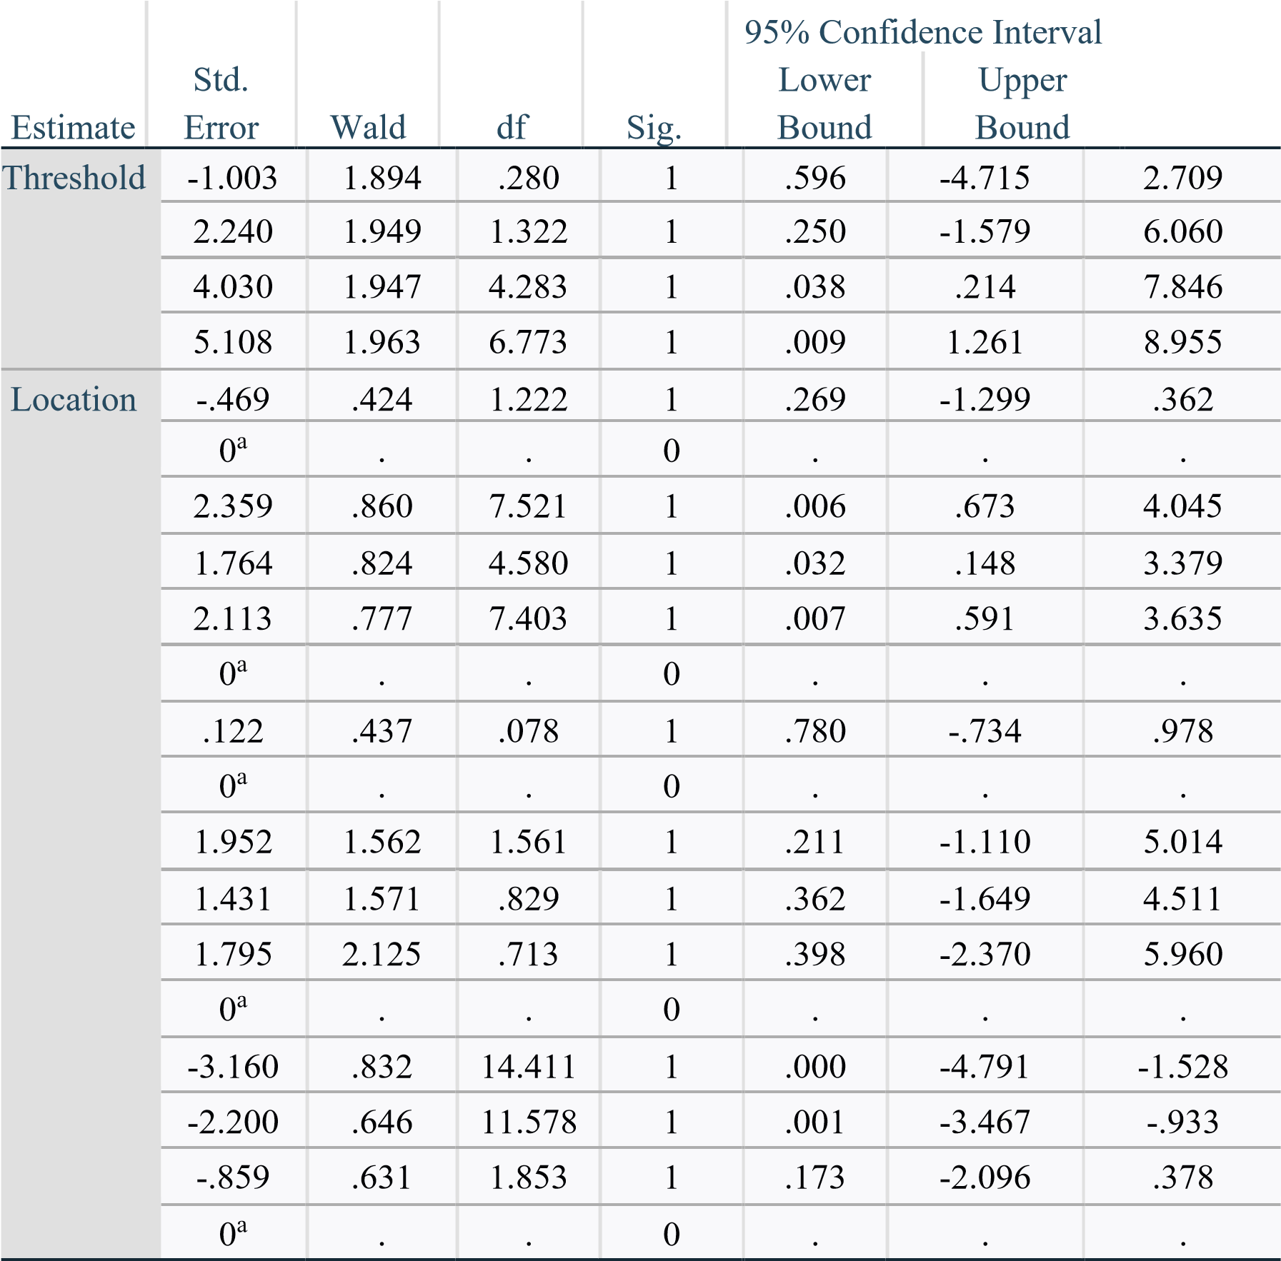

Water Quality Level 1 (p = 0.006), Level 2 (p = 0.032), and Level 3

(p = 0.007) significantly influence satisfaction compared to Level 4.

**Table 10**: Parameters estimates for dependent and independent value Positive coefficients indicate that higher perceived water quality increases satisfaction with drinking water costs. Efficiency of the **Water Distribution System:** Efficiency Level 1 (p < 0.001) and Level 2 (p = 0.001) significantly influence satisfaction compared to Level 4. Negative coefficients indicate that lower efficiencyreduces satisfaction.

1. **Insignificant Predictors (p ≥ 0.05): Daily Water Consumption:** The p-value (0.269) indicates no significant effect on satisfaction. **Awareness of Contamination:** The p-value (0.780) shows no significant effect. **Willingness to Pay for Better Water:** The pvalues for all levels (0.211, 0.362, and 0.398) indicate no significant influence on satisfaction.
2. **Interpretation of Thresholds:** The threshold estimates indicate the points at which respondents shift from one level of satisfaction to another. For example:The threshold 4.030 (p = 0.038) shows a significant difference between the third and fourth satisfaction levels.The threshold 5.108 (p = 0.009) shows a significant difference between the fourth and fifth levels.

The analysis reveals that perceived water quality and the efficiency of the water distribution system are the most influential factors affecting satisfaction with drinking water costs. Improving water quality and distribution efficiency can significantly enhance satisfaction levels. In contrast, factors like daily water consumption, awareness of contamination, and willingness to pay for better water do not significantly influence satisfaction.

#### 5.3.2 Hypothesis Testing

**Null Hypothesis (H0)**: There is no significant relationship between the independent variables (water consumption, perceived water quality, awareness of contamination, willingness to pay, and efficiency of water distribution) and satisfaction with the cost of drinking water.

**Alternative Hypotheses:**

**H1**: Higher daily water consumption has a positive effect on satisfaction with water cost.

**H2**: Better perceived water quality increases satisfaction with water cost.

**H3**: Awareness of contamination negatively impacts satisfaction with water cost.

**H4**: Higher willingness to pay for improved water quality positively affects satisfaction with water cost.

**H5**: Greater perceived efficiency of water distribution positively influences satisfaction with water cost.

|  |  |  |  |  |
| --- | --- | --- | --- | --- |
| **Variable** | **Estimate** | **p-value** | **Significance** | **Decision** |
| Daily Water  Consumption  (H1) | -0.469 | 0.269 | Not  Significant  (p > 0.05) | Fail to Reject H0 |
| Perceived  Water Quality  (H2) | 2.359 (L1) | 0.006 | Significant (p < 0.05) | Reject H0 |
| Awareness of  Contamination  (H3) | 0.122 | 0.780 | Not  Significant  (p > 0.05) | Fail to Reject H0 |
| Willingness to Pay (H4) | 1.952 | 0.211 | Not  Significant  (p > 0.05) | Fail to  Reject  H0 |
| Efficiency of  Water  Distribution  (H5) | -3.160 (L1) | <0.001 | Significant (p < 0.05) | Reject H0 |

**Table 11:** Hypotheses Test Result

The hypothesis testing results indicate that Perceived Water Quality (H2)and Efficiency of Water Distribution (H5) have statistically significant impacts on the outcome, as their p-values are below 0.05. Specifically, Perceived Water Quality (Estimate = 2.359, p = 0.006) shows a positive and significant effect, suggesting that individuals' perception of water quality plays a crucial role. Similarly, Efficiency of Water Distribution (Estimate = -3.160, p < 0.001) is also significant, indicating that inefficiencies in distribution negatively impact the outcome. However, Daily Water Consumption (H1**)**, Awareness of Contamination (H3**)**, and Willingness to Pay (H4**)** are not statistically significant (p > 0.05), meaning there is insufficient evidence to conclude that these factors have a meaningful effect.



**CHAPTER**

**SIX**

**Conclusion and Recommendations**

### 6.1 Conclusion

The findings of this research provide a comprehensive economic analysis of the drinking water supply system at Islamic University, Kushtia, evaluating key factors such as water quality, distribution efficiency, user satisfaction, cost-effectiveness, and sustainability. Through a mixed-method approach combining quantitative regression modeling, cost-benefit analysis (CBA), and user perception surveys, the study assessed the financial and operational efficiency of the existing water infrastructure. The results indicate that perceived water quality and distribution efficiency are the most significant factors influencing user satisfaction. The study found that the perception of water quality has a strong positive impact on satisfaction (p = 0.006), highlighting the importance of improving purification systems and water safety measures. Similarly, distribution efficiency was found to be a critical concern (p < 0.001), as inconsistent supply, low pressure, and infrastructure inefficiencies significantly reduce satisfaction and accessibility.

Despite evidence of contamination, including iron, arsenic, and microbial pollutants, awareness of these issues did not significantly influence satisfaction or willingness to pay for improvements. This suggests that there is a low perceived risk awareness among students and staff, which may impact the urgency of demand for change. Additionally, financial constraints were identified as a major limiting factor, with only 37% of respondents willing to pay between 100–200 BDT per month for better water quality. Although 48% of users expressed dissatisfaction with water costs, the study suggests that economic affordability is a key barrier to increased investment in water infrastructure. This finding underscores the need for costeffective solutions and alternative funding models, such as publicprivate partnerships, to finance necessary improvements.

Furthermore, the study raises concerns about the financial sustainability of the university’s water supply system. The current financial model lacks transparency, and operational costs remain high, with limited budget allocation for infrastructure upgrades. The costbenefit analysis (CBA) suggests that targeted investments in water purification, leak detection, and renewable energy-powered distribution systems could yield long-term financial and environmental benefits. These improvements could enhance both the affordability and sustainability of water supply while ensuring compliance with health and environmental standards. Addressing these financial and operational inefficiencies is crucial for ensuring the long-term viability of the system.

Based on these findings, the university must prioritize strategic interventions to address water quality issues, distribution inefficiencies, and financial sustainability. The absence of a centralized water management plan and sustainable funding sources indicates an urgent need for institutional reforms in how water supply is managed, financed, and maintained. To further strengthen the research, future studies should expand the sample size and conduct a longitudinal assessment to evaluate seasonal fluctuations in water demand and quality. Additionally, incorporating GIS mapping and real-time monitoring data would help track infrastructure inefficiencies, while further research on alternative pricing strategies, such as tiered pricing models or public-private collaborations, could improve financial sustainability while maintaining affordability.

Ensuring safe, affordable, and sustainable drinking water is not just a logistical necessity but a fundamental human right that directly impacts public health, student productivity, and institutional efficiency. The Islamic University, Kushtia, must take immediate, data-driven action to reform its water management policies, upgrade infrastructure, and implement cost-effective, long-term solutions. By leveraging scientific evidence, financial planning, and sustainable technologies, the university can transform its water supply system into a model of economic and environmental sustainability, ensuring access to clean and affordable water for generations to come.

### 6.2 Recommendations

To address the critical issues identified in this research and ensure a sustainable, cost-effective, and efficient drinking water supply system at Islamic University, Kushtia, the following strategic, policy-driven, and technologically advanced recommendations are proposed.

#### 1. Enhancing water quality through advanced purification technologies

Given the significant impact of perceived water quality on user satisfaction, the university must prioritize state-of-the-art water purification technologies. The implementation of reverse osmosis (RO) filtration systems, ultrafiltration (UF) membranes, and UV disinfection units at key distribution points can significantly improve water quality. Additionally, real-time sensor-based contamination detection systems should be integrated to monitor iron, arsenic, and microbial pollutants, with automated alerts for immediate intervention.

#### 2. Optimizing water distribution efficiency with smart infrastructure

The study revealed substantial inefficiencies in water distribution, leading to inconsistent pressure and supply disruptions. To address this, the university should deploy an AI-driven smart water management system incorporating IoTenabled leak detection sensors, automated pressure regulators, and real-time flow monitoring. These technologies can identify inefficiencies, reduce water loss, and ensure equitable distribution across all campus facilities. Furthermore, a zonal distribution system with decentralized pumping stations can enhance pressure stabilization and prevent supply bottlenecks.

#### 3. Implementing a data-driven financial model for sustainability

The university must transition from its current financially unsustainable model to a cost-effective and transparent financial framework. A tiered pricing strategy should be introduced, where students and staff pay a minimal fee based on consumption brackets while ensuring subsidized access for financially constrained users. Additionally, the institution should seek public-private partnerships (PPPs) to fund infrastructure upgrades and long-term sustainability initiatives. A dedicated water management fund should be created to allocate resources efficiently, ensure cost recovery, and finance future improvements.

#### 4. Advancing sustainability through renewable energy integration

To mitigate operational costs and promote environmental sustainability, the university should integrate solar-powered water pumping systems and rainwater harvesting units. These initiatives will reduce reliance on conventional energy sources, thereby lowering long-term expenses. Implementing greywater recycling systems for non-drinking purposes, such as irrigation and sanitation, will further enhance sustainability. Additionally, an AI-powered predictive analytics model should be employed to forecast water demand patterns and optimize supply allocation accordingly.

#### 5. Strengthening institutional governance and policy frameworks

The university should establish a Water Resource Management Committee (WRMC), comprising experts in economics, environmental engineering, and public health, to oversee policy implementation, budgeting, and compliance with national water safety regulations. The WRMC should conduct biannual audits of water infrastructure and publish findings in a publicly accessible report, ensuring transparency and accountability. Moreover, the development of a comprehensive Water Safety Plan (WSP) will institutionalize best practices in risk assessment, emergency response, and infrastructure resilience.

6. **Raising awareness and fostering behavioral change** Despite scientific evidence of contamination, awareness of waterborne risks remains low. A university-wide awareness campaign should be launched, leveraging digital media, interactive workshops, and real-time water quality dashboards to educate students and faculty on contamination risks, conservation strategies, and the importance of sustainable water usage. Encouraging participatory governance by involving students in water conservation initiatives and monitoring efforts can foster a culture of responsibility and sustainability.

Finally, we can summarize that by implementing these multidimensional, data-driven, and technologically advanced solutions, Islamic University, Kushtia, can transform its water supply system into a model of economic efficiency, environmental sustainability, and institutional resilience. Strategic investments in smart infrastructure, renewable energy integration, financial transparency, and behavioral change will ensure long-term viability, ultimately safeguarding public health and resource security for future generations.

#### References

Ali G., Khalid M., Abbas S., Murtaza M., 2021*, ( Drinking-water efficiency, cost of illness, and peri-urban society: An economic household analysis),*

[(https://doi.org/10.1371/journal.pone.0257509*)*](https://doi.org/10.1371/journal.pone.0257509)*.*

Boukhari S., Abida H., Djebbar Y., 2020*, (Economic analysis of drinking water services, case of the city of Souk-Ahras (Algeria),*

*(Water Practice & Technology Vol 15 No 1 17 doi:*

*10.2166/wpt.2019.0820).*

Mishra V., Dasani P., Gandhi N., Mehta D., 2016*, (Analysis of Water Supply in Urban Areas), (GRD Journals | Global Research and Development Journal for Engineering | Recent Advances in Civil Engineering for Global Sustainability | March 2016).*

Merchán-Sanmartín B., Carrión-Mero P., Suárez-Zamora S., 2022*, (Drinking Water Master Plan for The Management of Water Resources On a University Campus), (WIT Transactions on Ecology and the Environment, Vol 258, © 2022 WIT Press www.witpress.com).*

Sjöstrand K., Sjöstrand A., Söderqvist T., Rosen L., 2019*, (CostBenefit Analysis for Supporting Intermunicipal Decisions on Drinking Water Supply), (J. Water Resour. Plann. Manage., 2019, 145(12): 04019060).*

Islam, M. S., & Hossain, M. A. (2024**).** *Optimizing Rural Drinking Water Supply Infrastructure in Coastal Bangladesh. Water*

*Resources Research, 60(2), e2021WR029621.*

<https://doi.org/10.1029/2021WR029621>

Rahman, M. M., & Akter, S. (2023**).** *Exploring the Quality of Bottled*

*Drinking Water in Dhaka, Bangladesh: A Focus on Physicochemical Parameters, Heavy Metals, and Microbial Contamination. International Journal of Research and Innovation in Applied Science (IJRIAS), 8(5), 23-35.*

<https://doi.org/10.1016/j.watres.2023.120184>

Khan, A. R., & Jahan, S. (2023**).** *Analysis of Dhaka's Potable Water and Sanitation Services in Achieving SDG 6. Journal of Environmental Innovation and Climate Change, 7(1), 45-58.*

<https://doi.org/10.1016/j.scitotenv.2023.164729>

Smith, J. P., & Williams, H. R. (2025**).** *Contamination of Drinking Water with Unregulated Chemicals in the United States. Environmental Science & Technology Letters, 12(1), 77-89.*

<https://doi.org/10.1021/acs.estlett.5c00023>

Haider, A., Islam, M. M., Khatun, M. H., & Shoeb, M. (2024)**.** *Exploring the Quality of Bottled Drinking Water in Dhaka, Bangladesh: A Focus on Physicochemical Parameters, Heavy Metals, and Microbial Contamination. International Journal of*

*Research and Innovation in Applied Science (IJRIAS), 9(10), 121-*

*130.*<https://doi.org/10.51584/IJRIAS.2024.910012>

# Annex

Questionnaire On

**An Economic Analysis of Drinking Water Supply At Islamic University, Kushtia.**

***Section 1: Basic Information***

**1.**

**Name**

*

**2.**

**Session**



**2.**



**Department**



*



(



Short



answer



text)



**3. What is your age? * (**Multiple choice)

O Below 20 O 20–24 O 25–30 O Above 30

## 4. What is your gender? * (Multiple choice)

O Male O Female

|  |  |
| --- | --- |
| ***Section 2: Water Accessibility and Usage*** | |
|  |  |

1. **How often do you use the drinking water supplied by the university?**

**o** Daily o Occasionally o Rarely

1. **How would you rate the availability of drinking water on campus?**

Always available

Frequently available

Occasionally unavailable Often unavailable

1. **Do you use alternative sources for drinking water besides the university supply**?

## Yes/No

**8. On average, how much water do you consume daily from the university supply?**

* Less than 2 liters
* 2–5 liters
* More than 5 liters

***Section 3: Water Quality Perception***

9. **How do you perceive the quality of drinking water provided by the university?**

o Excellent o Good o Neutral o Poor o Very poor

10.  **Are you aware of any reported contamination in the water supply (e.g., arsenic, iron, lead, cadmium, chloride and other toxic substance) ?**

## Yes/ No

1. **Have you or someone you know experienced health issues specially Diarrhea, Typhoid fever, Cholera potentially related to the university's drinking water ?**

**Yes**

**No**

|  |  |
| --- | --- |
| ***Section 4: Economic Aspects*** | |
|  |  |

1. **How satisfied are you with the cost of accessing drinking water on campus ?**

***Very satisfied***

***1***

***2***

***3***

***4***

***5***

***Very dissatisfied***

1. **How much are you willing to pay per month for improved drinking water quality and reliability?**

*Below 100 BDT*

*100-200 BDT*

*200-300 BDT*

*Above 300 BDT*

1. **Do you think the university authority allocates sufficient budget for water supply infrastructure and maintenance ?**

## (Yes/No)

***Section 5: System efficiency and sustainability***

1. **How would you rate the efficiency of the current water**

**distribution system?**

Very efficient

1

2

3

4

5

Less efficient

1. **Do you think the university's water supply system is sustainable for future needs?**

**Yes/No**

1. **Which of the following improvements do you think are**

### necessary for the water supply system ? (You can select more than one)

Improved water quality

Better infrastructure for distribution

Increased budget for maintenance

Enhanced monitoring of water quality

1. **Would you support initiatives like water recycling or renewable energy for water pumping?**

**Yes/No**

1. **Would you support initiatives to get better water quality to set up water purifying machine in specific area of the campus?**

## Yes No

20. **What is the most significant challenge you face with the university’s drinking water system?** (Long answer text)



**Ans:**



### 21. Please provide any suggestions to improve the university’s drinking water supply? (Long answer text)



**Ans:**



.

